APPLICATION FOR EMPLOYMENT

Forename: |  | Middle Name:
Surname: |  | Maiden Name (if applicable):

Address:
Post Code:
Home Tel No: |  | Date of Birth:
Mobile No: |  | Age (next birthday):
e-mail:

Marital Status: |  | Ages of Any Children & Gender:
No of Dependants:

Driving Licence: |  | Any Disqualifications:
Years Held: |  | Any Points etc:

Health: | Do you have a history of any illnesses, disabilities, allergies or any other condition whatsoever that could or may affect your work or employment? | Yes |  | No
 | Also do you or any member of your family have heredity illnesses? | Yes |  | No

If Yes to any of the above, clearly state on a separate sheet and attach

Smoking: |  | Do you Smoke? |  | Yes |  | No

If Yes, How Many Daily
 |  | Have you ever Smoked? |  | Yes |  | No
If Yes, Please state  when you stopped |  | For how many Years did you smoke? |  | How Many a Day?

Criminal Record: | Have you got a Criminal Record? | Yes |  | No

If Yes, please state exact details on a separate sheet and attach

Present Employer (in strictest confidence):
Company Name:

Address:
Post Code:
Tel No:
Fax No:
Website:
Present Job Title:
Present Job Description:
Reason you wish to change
Present Employer:
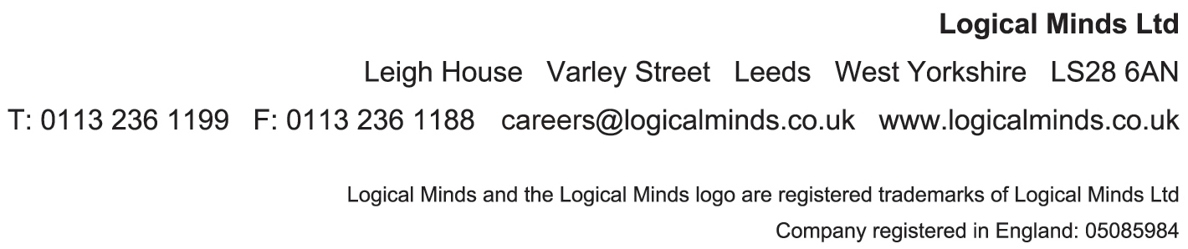

PREVIOUS EMPLOYMENT:
From (Date) | Until  (Date) | Company Name | Location (City) | Job Title | Job Description/Main Duties | Salary | Reason for Leaving

EDUCATION & TRAINING:
From (Date) | Until  (Date) | Course Title | Location of Training | Qualifications Gained | Description of What You Felt You Gained/Learned From It

REFERENCES:
Employment Reference 01 |  | Employment Reference 02 |  | Educational/Personal Reference 03
Reference Name: |  | Reference Name: |  | Reference Name:
Position: |  | Position: |  | Relationship:
Company Name: |  | Company Name:
Address: |  | Address: |  | Address:
Post Code: |  | Post Code: |  | Post Code:
Tel No: |  | Tel No: |  | Tel No:
Fax No: |  | Fax No: |  | Fax No:
e-mail: |  | e-mail: |  | e-mail:

PERSONAL

Why are you applying for this position and what do you hope to gain from it?

What Special Qualities would we benefit from if we employ you?
Hobbies/Interests:
Please could you be kind enough to advise where you saw our advertisement:

